MARCH 2024


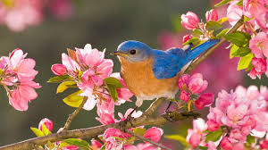
Spring is just around the corner, boating season not far behind.

WANTED
The squadron is in need of a Webmaster.
Great benefits, Great pay.
Contact Commander Murray mrthompson15@gmail.com

Membership

If you have issues renewing or questions, please contact your Hamilton Membership Officer,
Glen Carruthers at 905-929-8127 or g.carruthers@rogers.com

Need a new flag?
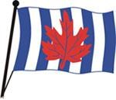
Contact Marney Warby @ 905-389-5719


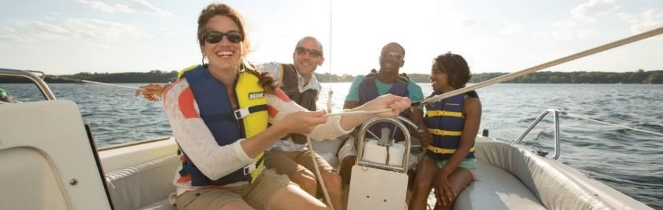

ARE YOU & YOUR BOATING FRIENDS LEGAL TO OPERATE A VHF RADIO? IT’S THE LAW.

Restricted Operators Certificate Marine (VHF)
Start date: April 11, 2024 Last day to register March 17th
Course length: 3 Thursday nights $125.00
Start time: 1900, 7 p.m.
Location: Macassa Bay Yacht Club, 80 Harbour Front Drive, Hamilton

Register for classes at boatingcourses.ca
Need assistance, email me, ronwarby46@gmail.com

Set sail with savings

Get ready for an amazing boating season on Parks Canada’s historic canals and waterways! Until March 31, 2024, take advantage of our 20% discount on seasonal lockage permits and receive 10% off on a mooring permit when you buy both together. Don’t miss out on these incredible deals!
 Contact Parks Canada at Parksorders.ca

Recreation Vessel Courtesy Check (RVCC)
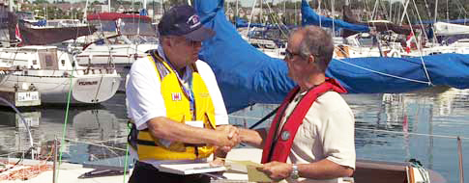

This courtesy check program is offered by CPS-ECP to promote boating safety.
But it requires volunteers to approach boaters and perform simple inspections.
If you would be interested in taking part in this program contact Tom.
Tom Dunmore 905-516-4478 or thdlaw@gmail.com

Dry Rot created and distributed by Ron Warby, AP

